Tripping Bracket Rule Design
TrippingBracketRulesDesign.doc
status:draft
revision history: 0.1
Creation date: January 23, 2004
Revision date:
Original author: Jonathan Stephenson

Table of Contents
1. Revision History 3
2. Introduction 3
2.1 References 3
2.2 Definitions 3
3. Conceptual Design (high level) 4
3.1 Overview 4
3.2 Directory Structure 4
3.3 Algorithm 4
4. Detail Design 5
4.1 Types of Classes, Interfaces and methods 5
4.2 Connected 6
4.2.1 Non-circular cross sections 6
4.2.2 Circular cross sections 6
4.2.3 Calculating the Fillet Offset 7
4.3 Error Handling 7
4.4 Technical review, resolve issues 7
5. External Dependencies 7
6. Unresolved Issues 7

Revision History
Rev | Status | Author | Date | Reason
0.1 | Draft | Jonathan Stephenson | 1/15/04 | Initial release

Introduction
This document is intended to be referenced by the author of the tripping bracket rules. The primary responsibility of the rule is to compute the offset for each definition point of the tripping bracket if that definition point is connected at least in part to a profile. The rule writer must decide how simple or complex the method should be. The rule is passed the thickness of the tripping bracket and the element that it is connecting to and it then determines which keypoint to connect to and how much it should offset from that keypoint in the u and v direction to compensate for welding. The supplied rule is intended to be used as an example when developing a custom tripping bracket rule. It provides examples of data caching, fillet offset computations, and basic keypoint selection decisions.
This document borrows heavily from the work on the tripping stiffener rule design.

References
1 | Symbol 2D Help | M:\Common2D\Symbol2D\Doc\Symbol2Dhelp409.chm
2 | Cross Section Definitions | M:\ShipCatalogData\BulkLoad\DataFiles\StructXsections.xls
3 | Tripping Stiffener Rules Design | S:\ShipStructure\Data\StiffenerBetweenElementsRule\Doc

Definitions
keypoint | A point along the geometry of the cross section, defined in the symbol file, and used to specify the point on the connecting entity where the tripping stiffener should connect.
loadpoint and mounting point | The loadpoint is a keypoint along the mounting face of the profile. A load point defines a location where a profile cross-section will land on the profile system toe trace when placed within Intelliship. The terms loadpoint and mounting point are used interchangeably throughout this document.
definition point | One of the three points used to define the plane of the tripping bracket.

Conceptual Design (high level)

Overview
The rule is intended to be used by the client command and also by the middle-tier semantic. The client uses the rule to provide visual feedback during the creation and/or modification of the tripping brackets, while the semantic uses it only in the case of a modification. The rule was designed to operate independently on each definition point of the tripping bracket based on the concept of an “angle of approach”.
For simplification purposes, the context for the user (i.e. rule writer) was chosen to be the same 2D view used to define the profile cross-sections—that is the Symbol2D local co-ordinate system as defined by the RAD2D files bulkloaded into the catalog. Neither the mounting angle, nor the mounting face will cause the cross-section’s approach angle within its 2D space to change (e.g. an approach angle of 0°/360° is always equivalent to opening the cross-section’s RAD2D file and drawing a vertical vector down onto the cross-section). Because of this, it is not completely necessary for the rule to analyze the mounting face of the connecting profile when determining which keypoint to connect to, however, the mounting face is useful because it allows the rule to determine whether or not the mouse cursor is on the same side of the plate as the connecting entity.

Directory Structure
The tripping stiffener rule has the following directory structure:
In S:\ShipStructure\Data:
\TrippingBracketRule – contains the rule’s VB project and class
\Doc – contains related documentation
In S:\ShipStructure\Middle:
CreateTrippingBracket – contains the rule’s interface definition

Algorithm
The default implementation:
- Checks the approach angle to ensure validity
- Refreshes the cached items if necessary
- Selects cross-section family
- Selects mounting face
- Determines the range that the angle falls within
- If the angle is below the cross section (the rule writer must determine which angles are above and below the cross section by analyzing the mounting face):
  - Set the attachment load point = mounting point of connected element
- Else, sets the keypoint (and u and v offset, if necessary) based on the angle and mounting point of the connected element

Because the rule is called on mouse moves, it must be fast. In an effort to accomplish this, the rule is being passed strings of the cross-section family and size rather than the actual cross-section. Whatever cross-section data is used for offset computations by the rule, it caches. If the cross-section changes, the rule will retrieve the new data from the database.

Detail Design

Types of Classes, Interfaces and methods
The rule must implement the interface IJTrippingBracketRule defined in the PlaneByElementsRule.tlb type library. This interface contains one function definition, ProfileConnectOffsets. This method has the following signature:
Private Sub IJTrippingBracketRule_ProfileConnectOffsets_
(ByVal dPlateThick As Double, _
ByVal sCECrossSectionType As String, _
ByVal sCECrossSectionSize As String, _
ByVal eCEMountingFace As StiffenerRuleLib.ProfileFaceName, _
ByVal lCEMountingPoint As Long, _
ByVal dApproachAngle As Double, _
plAttachmentLoadPoint As Long, _
pdUOffset As Double, _
pdVOffset As Double)

Inputs:
SCECrossSectionType – the connecting entities cross-section type
SCECrossSectionSize - the connecting entities cross-section size
ECEMountingFace – the connecting entity’s mounting face
LCEMountingPoint – the connecting entity’s loadpoint
DApproachAngle – angle (in degrees) of the 2D vector that is between the mouse cursor and the intersection point of the connecting entity
Outputs:
PlAttachmentLoadPoint – keypoint on the connecting entity that the tripping stiffener will connect to.
PdUOffset – offset from the plAttachmentLoadPoint in the u direction
PdVOffset – offset from the plAttachmentLoadPoint in the v direction

This interface also contains error codes that can be raised by the rule (discussed in the “Error Handling” section).

Connected
It is not the responsibility of the rule writer to offset the connect point if the thickness direction of the tripping bracket is in the opposite direction of the orientation of the stiffener to which it is connecting. Performing this computation in the client would require complex functions, more input data, and would hinder performance. This adjustment is handled by the semantic.

Non-circular cross sections
Angle bars, BUTs, I beams, channel bars, and flat bars are relatively simple to deal with. The rule picks a key point based on the approach angle (and sometimes the mounting point of the connecting entity), and then calls a private function, CalcFilletOffset(), which computes the offset for welding.

Circular cross sections
Circular profiles require extra consideration:

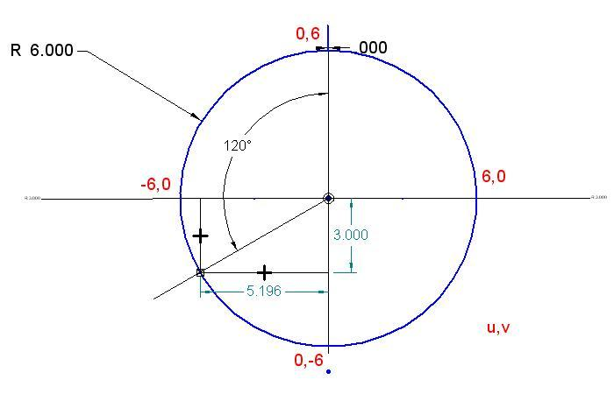
*example from table below

These u,v offsets can be computed by:
u offset = r * sin(180 + approachAngle)
v offset = r * cos(approachAngle)

degrees | u | V
0° | 0 | 0
30° | -3 | 5.196
90° | -6 | 0
*120° | -5.196 | -3
180° | 0 | -6
210° | 3 | -5.916
270° | 6 | 0
300° | 3 | 5.916

Calculating the Fillet Offset
The offset for welding provided simply checks to see what range the depth of the cross section falls within and then decides an offset based on that. Because the depth of some cross sections isn’t available, the length of the face that is normal to the mounting face is used (e.g. if the mounting face is the bottom, the web length will be used). This could be more complex, using other attributes of the cross section that are stored in the catalog, if necessary.

Error Handling
The most common error used in this code is E_INVALIDARG. This error can be used when the angle passed in is less than 0 or greater than 360 degrees. Also can be used if some combination of arguments is invalid.
There is also a rule specific error PBR_E_NO_SOLUTION. This error is used when the angle passed in is inappropriate for specific cross-section that the tripping bracket is trying to lap, or any other invalid set of arguments.
There is no trivial way to allow rule writers to add custom error codes to be posted to the ToDo list because this requires access to the Rose model. For debugging purposes, the rule writer could add a call to the VB MsgBox function, so that they can see why a failure occurred.

Technical review, resolve issues

External Dependencies
This project is only dependent on the CreateTrippingBracket type library project, which generates the TrippingBracketRule.tlb typelib using the TrippingBracketRule.idl file in the \ShipStructure\Middle\CreateTrippingBracket\Src directory.

The rules are heavily dependent on the definition of the profile cross-sections—especially the keypoints. Changes to the symbol files must be co-ordinated with updates to the rule. These symbol files are located in \ShipStructure\Data\Profile Xsections.

Unresolved Issues
None known.

